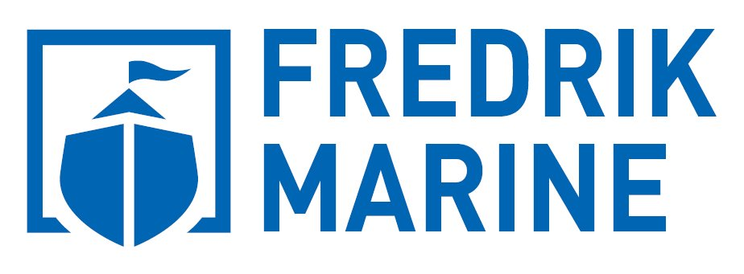

**+65 3112-1688  
gethelp@fredrikmarine.com**

**SatChat Communications**

**Fredrik Marine**







**SatChat is an inexpensive satellite communications solution** that enables the transparent and direct routing of one or many local phone numbers to satellite phones. The SatChat service extends to phone numbers in more than fifty countries.

**Primary benefit:** SatChat provides a cost savings of up to 50% as compared to direct calls to satellite phone numbers through Inmarsat, Iridium, or Thuraya satellites.

**SatChatFeatures**

* A dedicated local phone number for each satellite phone and instant number activation
* Satellite telephone numbers can be changed without changing local number
* Pre-paid & post-paid SatChat accounts
* Real-time billing with online access to all call records and account balances
* Multiple SatChat numbers can be combined into group billing

**SatChat Advantages**

* A cost savings of up to 90% for calls placed to satellite phone numbers
* Bill administration for vessels and fleets
* Convenience in managing local-connection number assignments
* PIN code restrictions to protect against unwanted callers (optional)
* Blacklisting and Whitelisting of callers (optional)